FALL FOR
SCARECROWS
AT CALEB SMITH STATE PARK PRESERVE
Join the fun of creating original, humorous scarecrows to decorate the autumn scene at our park. Call/email to reserve a frame on which to build your scarecrow for display. Free event is open to families, individuals and clubs, and is sponsored by Friends of Caleb Smith Preserve.

Where: Caleb Smith State Park Preserve
Route 25, Smithtown, NY

Reserve frame by calling Park office @
631/265-1054 or by emailing:
calebfriends@aol.com

Pick up a reserved scarecrow frame @
park office between October 1st and 5th. Park is
open Wednesdays - Sundays 8 AM-4 PM.
Scarecrow Trail will be displayed
throughout November.
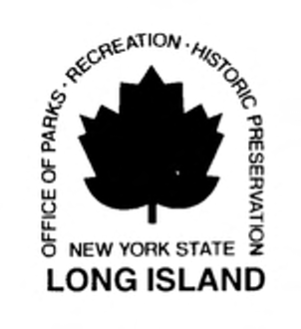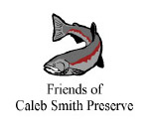
No parking fee after Labor Day

